**Lab Report: 02**

**Title: Scan conversion**

*Course title: Computer Graphics Laboratory*

*Course code: CSE-304*

*3rd Year 1st Semester Examination 2022*

**Date of Submission**: 04/06/2023



**Submitted to-**

*Dr. Mohammad Shorif Uddin*

*Professor*

*Department of Computer Science and Engineering*

*Jahangirnagar University*

*&*

*Dr. Morium Akter*

*Associate Professor*

*Department of Computer Science and Engineering*

*Jahangirnagar University*

*Savar, Dhaka-1342*

| Class Roll | Registration Number | Name |
| --- | --- | --- |
| 354 | 20200650724 | Irtifa Haider Ahona |

**Experiment No. : 01**

**Experiment Title : Scan conversion of a Circle using Midpoint Algorithm**

**Code:**

#include<bits/stdc++.h>

#include <graphics.h>

using namespace std;

int main()

{

int gd = DETECT, gm;

initgraph(&gd, &gm, " ");

setbkcolor(WHITE);

int x,y,r,x0,y0,d;

cout << "Enter the coordinates of the center: ";

cin >>x0>>y0 ;

cout << "Enter the radius of the circle: ";

cin >> r;

x=r;

y=0;

d=1-r;

while (y <= x)

{

putpixel(x + x0, y + y0, WHITE);

putpixel(-x + x0, y + y0, WHITE);

putpixel(x + x0, -y + y0, WHITE);

putpixel(-x + x0, -y + y0, WHITE);

putpixel(y + x0, x + y0, WHITE);

putpixel(-y + x0, x + y0, WHITE);

putpixel(y + x0, -x + y0, WHITE);

putpixel(-y + x0, -x + y0, WHITE);

y++;

if (d <= 0)

{

d += 2 * y + 1;

}

else

{

x--;

d += 2 * (y - x) + 1;

}

}

getch();

closegraph();

return 0;

}

**Output:**

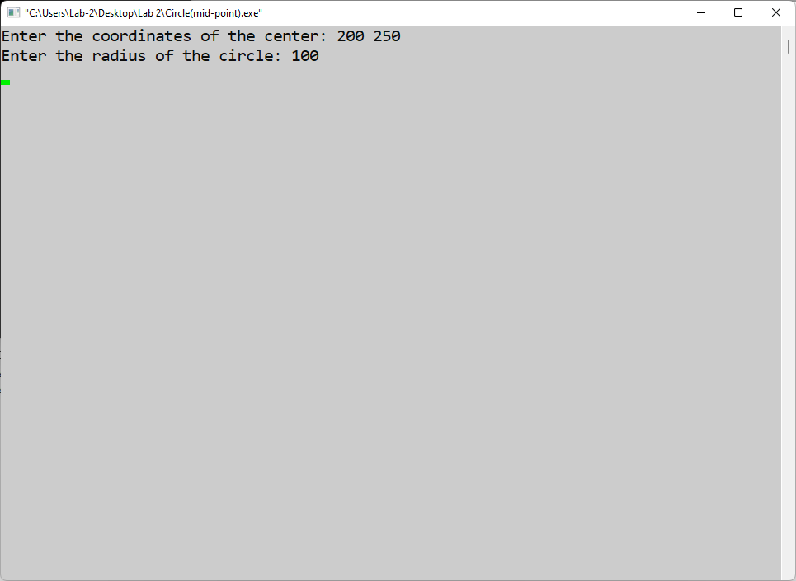

**Fig-01: The coordinates of center and value of radius of the circle as input**

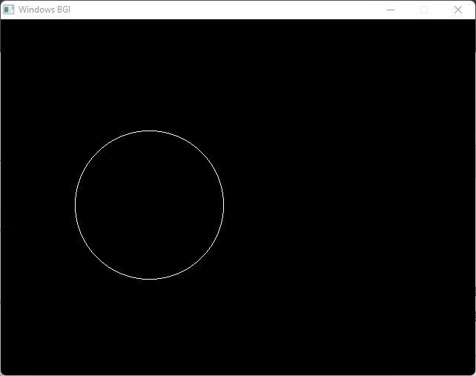

**Fig-02: The converted circle**

**Experiment No. : 02**

**Experiment Title : Scan conversion of a Ellipse using Midpoint algorithm**

**Code:**

#include<bits/stdc++.h>

#include <graphics.h>

using namespace std;

int main()

{

int gd = DETECT, gm;

initgraph(&gd, &gm, " ");

int xc, yc, rx, ry,x,y,Srx,Sry,TSrx,TSry,d;

cout << "Enter the coordinates of the center: ";

cin >> xc >> yc;

cout << "Enter the major radius & minor radius: ";

cin >> rx>> ry;

x=0;

y=ry;

Srx = rx * rx;

Sry = ry * ry;

TSrx = 2 * Srx;

TSry = 2 * Sry;

int px = 0;

int py = TSrx * y;

d = round(Sry - (Srx * ry) + (0.25 * Srx));

while (px < py)

{

putpixel(xc + x, yc + y, RED);

putpixel(xc - x, yc + y, RED);

putpixel(xc + x, yc - y, RED);

putpixel(xc - x, yc - y, RED);

x++;

px += TSry;

if (d < 0)

{

d += Sry + px;

}

else

{

y--;

py -= TSrx;

d += Sry + px - py;

}

}

d = round(Sry * (x + 0.5) * (x + 0.5) + Srx * (y - 1) * (y - 1) - Srx * Sry);

while (y >= 0)

{

putpixel(xc + x, yc + y, RED);

putpixel(xc - x, yc + y, RED);

putpixel(xc + x, yc - y, RED);

putpixel(xc - x, yc - y, RED);

y--;

py -= TSrx;

if (d > 0)

{

d += Srx - py;

}

else

{

x++;

px += TSry;

d += Srx - py + px;

}

}

getch();

closegraph();

return 0;

}

**Output:**

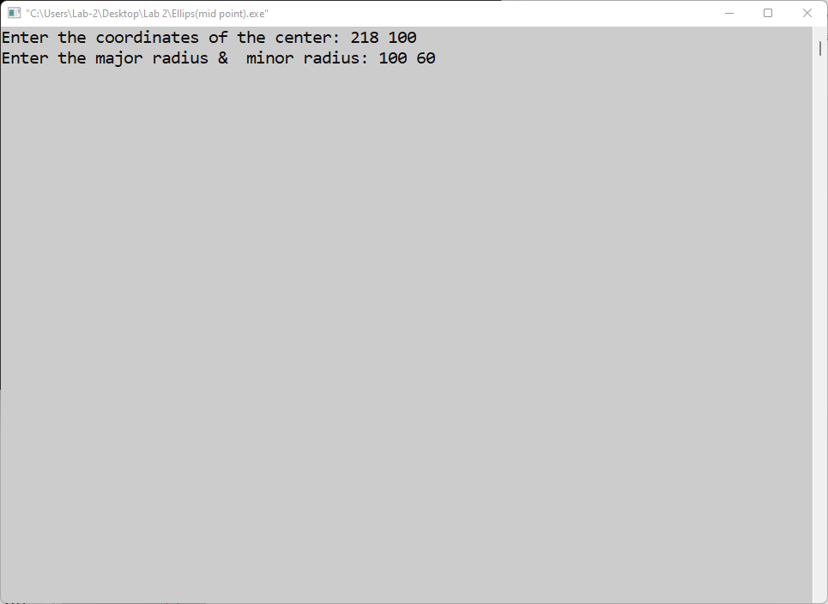

**Fig-01: The coordinates of center and the major and minor radius of the Ellipse as input**

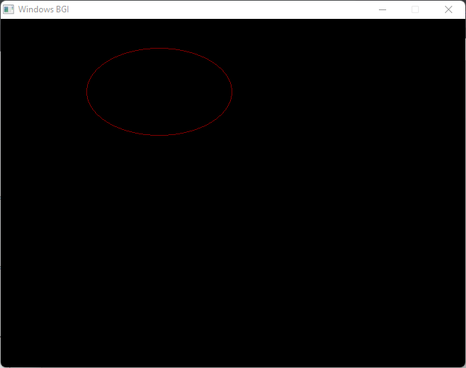

**Fig-02: The converted Ellipse**